**RESOLVE NOW (ONLINE COMPLAINT)**

**Introduction:**

Project Name: **Customer Registry App**

**Team Members:**

1. G. VASANTHA LAKSHMI ( Backend Developer)
2. P.SASHIKALA ( Supporter)
3. K. PRADEEP (Front End Developer)
4. D. UDAY KIRAN (Testing)

**Description:**

Welcome to RESLOVE NOW, The Resolve Now Project is an online platform designed to help patients, healthcare providers, and other stakeholders resolve complaints related to healthcare services in a fast and efficient manner. It provides a user-friendly interface that allows individuals to lodge complaints or express concerns about the quality of care they received, issues with healthcare facilities, or any administrative hurdles they encountered.

Collating and analyzing data from diverse customer interactions, the registry becomes a treasure trove of insights. These insights guide strategic decisions, aiding in the development of targeted training programs, refined service protocols, and streamlined processes. Consequently, customer care teams can proactively address recurring issues, offer personalized assistance, and curate a more satisfying experience for each customer.

In a world where customer satisfaction can make or break a brand, the Customer Care Registry emerges as an indispensable asset. It epitomizes a commitment to not only resolving issues but understanding the customer journey holistically. As businesses continue to evolve, the registry remains a steadfast ally, fostering lasting customer relationships built on trust, efficiency, and genuine care.

**Features:**

1. Centralized Complaint Management System

A unified platform to log, track, and resolve patient complaints efficiently.

Easy access for healthcare providers to review and act upon complaints in real time.

2. Automated Complaint Acknowledgement

Immediate confirmation to patients when a complaint is filed.

Provides a sense of transparency and reassurance for the patient that their concern is being addressed.

3. Real-Time Tracking and Updates

Patients can track the status of their complaints through an online portal or mobile app.

Automatic notifications when there are updates on their complaint status.

4. Root Cause Analysis

Identifying the underlying causes of recurring issues, not just addressing the symptoms.

Helps improve patient care processes and eliminate common complaints.

5. Integrated Feedback System

Collecting feedback from patients after their complaint is resolved to ensure satisfaction with the outcome.

Ensures that healthcare providers continuously improve based on real patient experiences.

6. Multichannel Support

Complaints can be filed via multiple channels like phone, email, web forms, or even through social media.

A flexible system that ensures patients can easily raise concerns in a way that's most convenient for them.

7. Personalized Responses and Solutions

Addressing each complaint in a personalized manner, offering tailored resolutions to the patient’s specific issue.

Avoiding generic responses that may frustrate the customer further.

8. Escalation Process

Clear pathways for escalating more serious complaints to senior management or relevant authorities.

Ensures complex issues are dealt with promptly and appropriately.

9. Data Analytics and Reporting

Collecting data from complaints to identify patterns, frequently mentioned issues, or areas that need improvement.

Provides healthcare administrators with insights to refine policies and practices.

10. Patient Education and Communication

Educating patients about the complaint process and how it can be used to improve their healthcare experience.

Ensuring transparent communication about what will happen next in the process.

11. Resolution Timeliness and Accountability

Defining clear timelines for resolving complaints.

Holding healthcare providers accountable for addressing issues within set timeframes

**Purpose:**

**Efficient Resolution of Complaints**

**Purpose:** The primary goal of the Resolve Now project is to provide a fast, effective, and transparent process for resolving patient complaints.

Why it's important: Healthcare systems often face challenges with addressing complaints in a timely manner, leading to frustration for patients. A structured project helps ensure that complaints are acknowledged quickly and resolved in a way that meets or exceeds patient expectations.

**2. Enhance Patient Experience**

**Purpose:** To improve the overall patient experience by addressing their concerns in a timely and empathetic manner.

Why it's important: Healthcare is an inherently stressful experience for many patients, and negative experiences can have long-term effects on patient trust and loyalty. By addressing complaints online in a responsive way, the project works to improve patient satisfaction.

**3. Transparency and Trust Building**

**Purpose:** The project aims to create transparency in the complaint-handling process, ensuring that patients feel their voices are heard and that their concerns are taken seriously.

Why it's important: Transparency helps to build trust with patients, showing them that their healthcare provider values their feedback and is committed to resolving issues.

**4. Improvement in Healthcare Services:**

**Purpose:** To identify recurring problems and patterns in complaints that can be used to improve the quality of care and services provided.

Why it's important: Healthcare providers can gain insights from complaint data that can lead to improved policies, procedures, and training, reducing the frequency of similar complaints in the future.

**Architecture:**

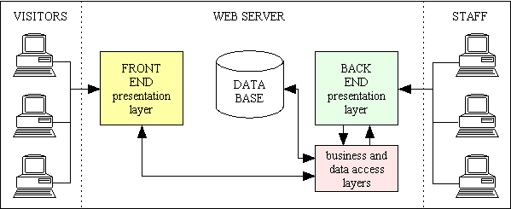

A customer registry is a system that stores and manages information about customers or clients. It typically includes details such as names, contact information, addresses, purchase history, preferences, and other relevant data. The technical architecture of a

customer registry involves the components and technologies used to build and operate the system effectively.

Here are some key elements commonly found in a customer registry technical architecture:

**Database:** The database is the central storage component that holds all customer data. It can be a relational database management system (RDBMS) like MySQL or PostgreSQL, a NoSQL database like MongoDB or Cassandra, or a combination of multiple databases depending on the requirements.

**API (Application Programming Interface):** The API serves as an interface for external systems to interact with the customer registry. It exposes a set of endpoints that allow authorized applications or services to perform operations such as creating, updating, retrieving, or deleting customer records. The API handles data validation, authentication, and authorization.

**Services:** Services are responsible for performing specific business logic and operations related to the customer registry. They can include services like customer registration,

authentication, customer profile management, data validation, and more. These services interact with the database and may communicate with each other as needed.

**User Interface:** The user interface component provides an interface for human users to interact with the customer registry system. It can be a web-based application, a mobile app, or even a command-line interface (CLI). The user interface communicates with the

API to perform actions such as searching for customers, updating information, or generating reports.

**Integration with Third-party Services:** A customer registry may integrate with various third party services to enhance its functionality. For example, it can integrate with email services to send notifications or marketing emails to customers. It can also integrate with SMS gateways for sending text messages. These integrations are typically based on event driven architecture, where certain actions or events trigger interactions with the third party services.

**Security and Authentication:** Security is a crucial aspect of a customer registry. It includes mechanisms for authentication and authorization to ensure that only authorized users or systems can access or modify customer data. Techniques like encryption, secure communication protocols (HTTPS), and user permissions play a vital role in securing the system.

**ERDiagram**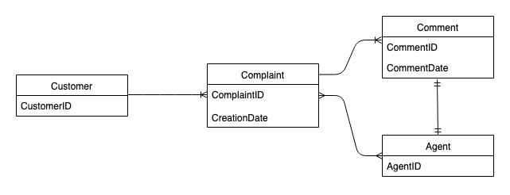

**Installation:**

**Install Node.js and npm**

First, you need to install Node.js, which includes npm (Node Package Manager)

•Download and install Node.js from here.

Set Project Directory

Create a new directory for your project:

mkdir my-mern-app

cd my-mern-app

Initialize your Project

Initialize a new Node.js project with npm:

npm init -y

Install Backend Dependencies

Install Express.js and other necessary backend packages:

npm install express mongoose

Create Backend Files

Create a basic structure for your backend:

• server.js: Main server file

•models/: Directory for Mongoose models

•routes/: Directory for Express routes

Install Frontend Dependencies

Install Create React App to set up the frontend:

npx create-react-app client

cd client

Run the React Application

Start the React development server:

npm start

Connect Frontend to Backend

In the React app, use Axios or Fetch to make API calls to your Express server. For example, create a new file api.js in your React app:

**Start Both Servers**

Run both servers (backend and frontend) simultaneously. You can use concurrently:

**npm start**

**Folder Structure:**

**Front end:**

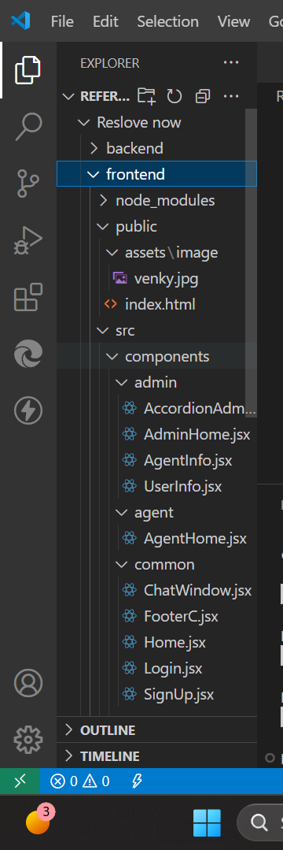

**Backend:**

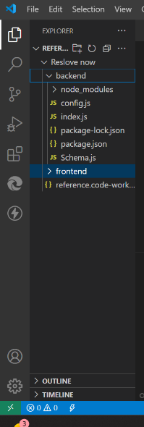

**Running the Application:**

**Frontend (Client) Server:**

Navigate to the client directory in your terminal.

Run the following command to start the frontend server:

npm start

This will start the frontend application, usually at <http://localhost:3000>.

**Backend (Server) Server:**

Navigate to the server directory in your terminal.

Run the following command to start the backend server:

npm start

This will start the backend API server, usually at http://localhost:8000 (or another port if specified).

Ensure that you have all the dependencies installed by running npm install in both the client and server directories before starting the servers.

**API Documentation:**

**API (Application Programming Interface):** The API serves as an interface for external systems to interact with the customer registry. It exposes a set of endpoints that allow authorized applications or services to perform operations such as creating, updating, retrieving, or deleting customer records. The API handles data validation, authentication, and authorization.

Services: Services are responsible for performing specific business logic and operations related to the customer registry. They can include services like customer registration,

authentication, customer profile management, data validation, and more. These services interact with the database and may communicate with each other as needed.

User Interface: The user interface component provides an interface for human users to interact with the customer registry system. It can be a web-based application, a mobile app, or even a command-line interface (CLI). The user interface communicates with the

API to perform actions such as searching for customers, updating information, or generating reports.

Integration with Third-party Services: A customer registry may integrate with various third party services to enhance its functionality. For example, it can integrate with email services to send notifications or marketing emails to customers. It can also integrate with SMS gateways for sending text messages. These integrations are typically based on event driven architecture, where certain actions or events trigger interactions with the third party services.

Security and Authentication: Security is a crucial aspect of a customer registry. It includes mechanisms for authentication and authorization to ensure that only authorized users or systems can access or modify customer data. Techniques like encryption, secure communication protocols (HTTPS), and user permissions play a vital role in securing the system.

**Authentication:**

**User Authentication:** User provides credentials (username and password) to the server.

**Session Creation:** If the credentials are correct, the server creates a session and stores user information in it.

**Session ID Issuance:** The server sends a session ID to the user.

**Session ID Storage:** The user stores the session ID (typically in cookies).

**Access Protected Routes:** The user includes the session ID in subsequent requests to access protected routes.

**User Interface:**

**Simplicity and Clarity**

* **Minimalist Design:** Use a clean and simple design to avoid overwhelming users with too much information. Focus on essential elements and remove any unnecessary clutter.
* **Clear Navigation:** Ensure that navigation is intuitive and straightforward. Use clear labels and icons to guide users through the app.

**User-Centric Design**

* **Personalization:** Tailor the user experience based on individual preferences and behaviors. Provide personalized recommendations and insights.
* **Accessibility:** Design the UI to be accessible to all users, including those with disabilities. Use appropriate color contrasts, font sizes, and screen reader compatibility.

**Security and Trust**

* **Secure Authentication:** Implement strong authentication methods such as two-factor authentication (2FA) or biometric authentication (fingerprint, facial recognition) to ensure user security.
* **Transparency:** Clearly communicate security measures and privacy policies to build trust with users.

**Consistency**

* **Uniform Design Language:** Maintain consistency in design elements such as colors, fonts, and button styles throughout the app. This helps users feel familiar and comfortable with the interface.
* **Consistent User Experience:** Ensure that the user experience is consistent across different devices and platforms (e.g., mobile, web).

**Security and Privacy**

**Login/Authentication:** Secure login for customers, support staff, and managers. This could involve password protection and two-factor authentication (2FA) for added security**.**

**Data Privacy:** Sensitive customer information should be encrypted and stored securely, following relevant privacy laws (e.g., GDPR, CCPA).

**Demo:**

**Home:**

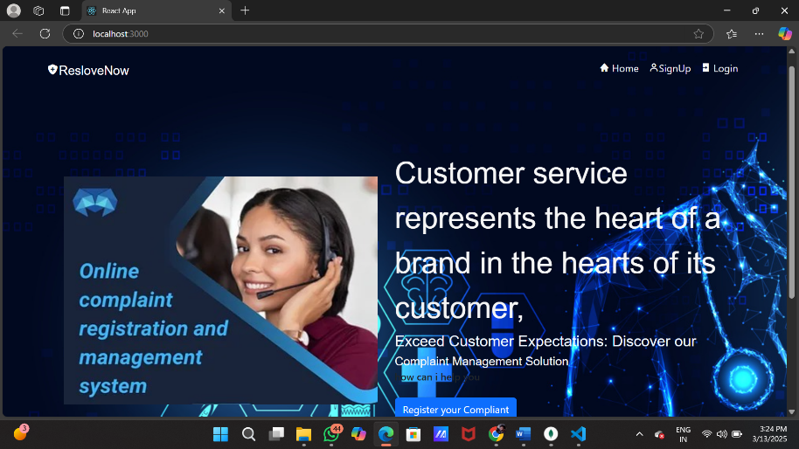

**Signup:**

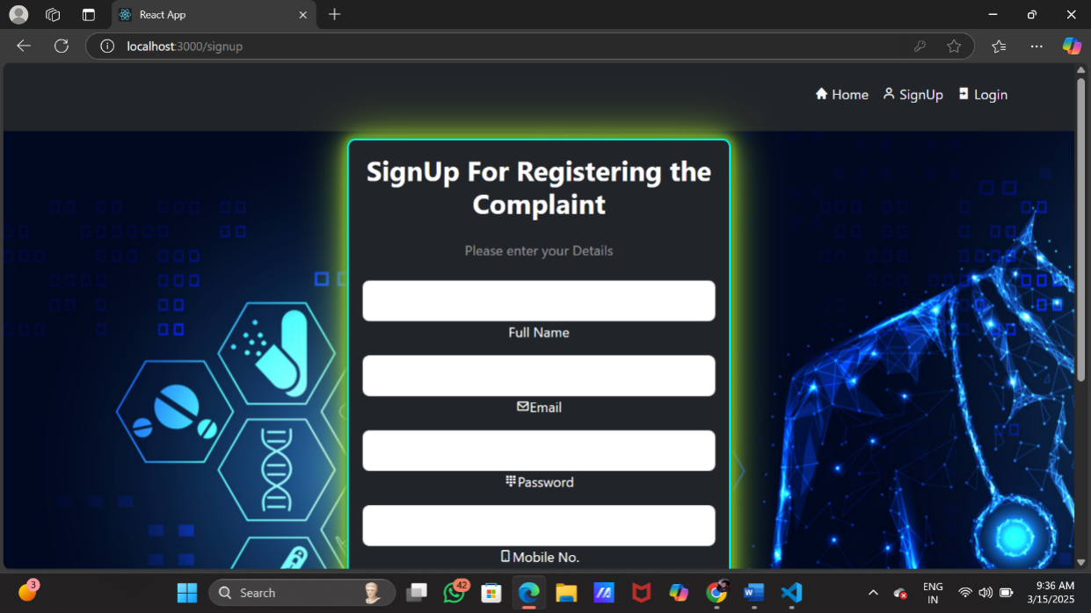

**Login:**

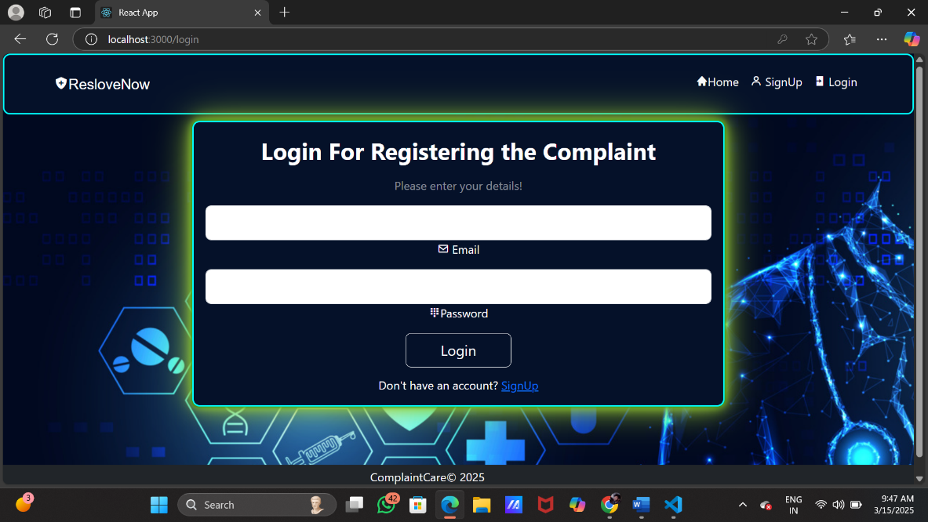

**Admin Dash Board:**

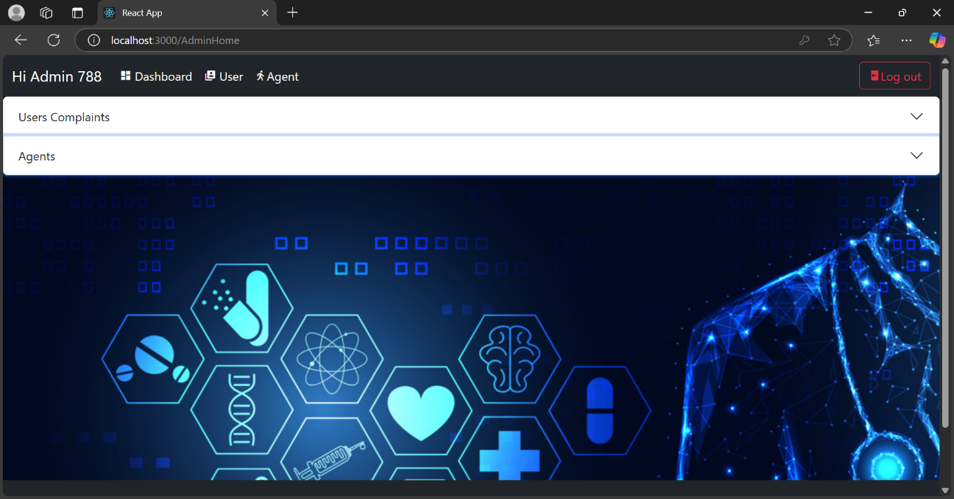

**Admin Users:**

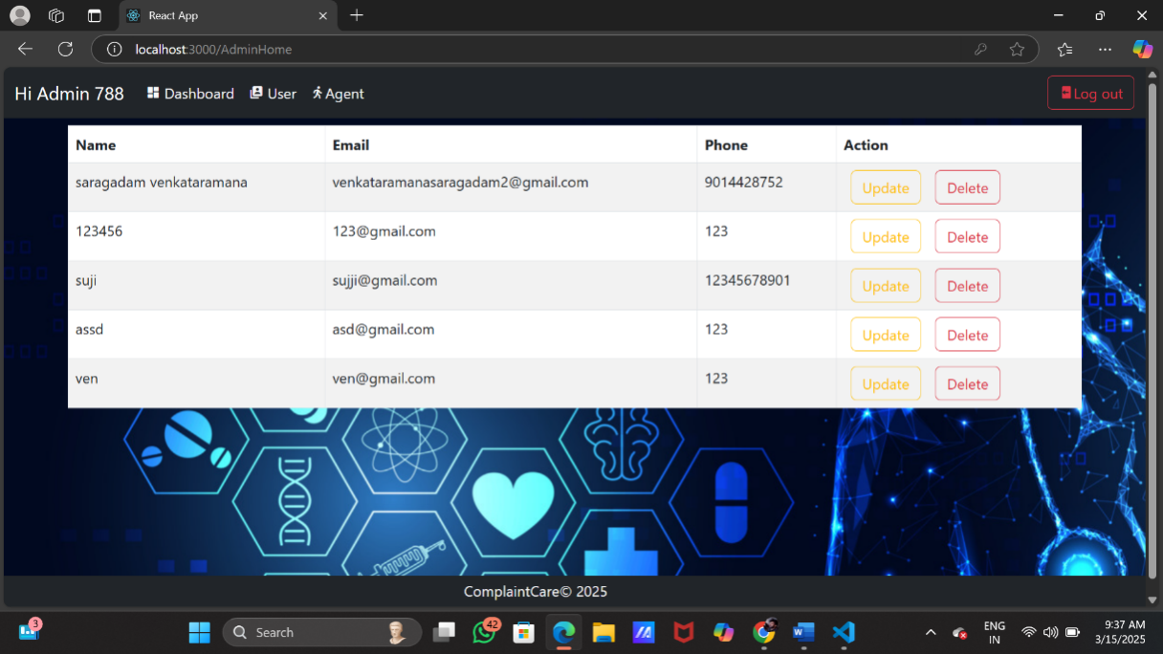

**Admin Agent:**

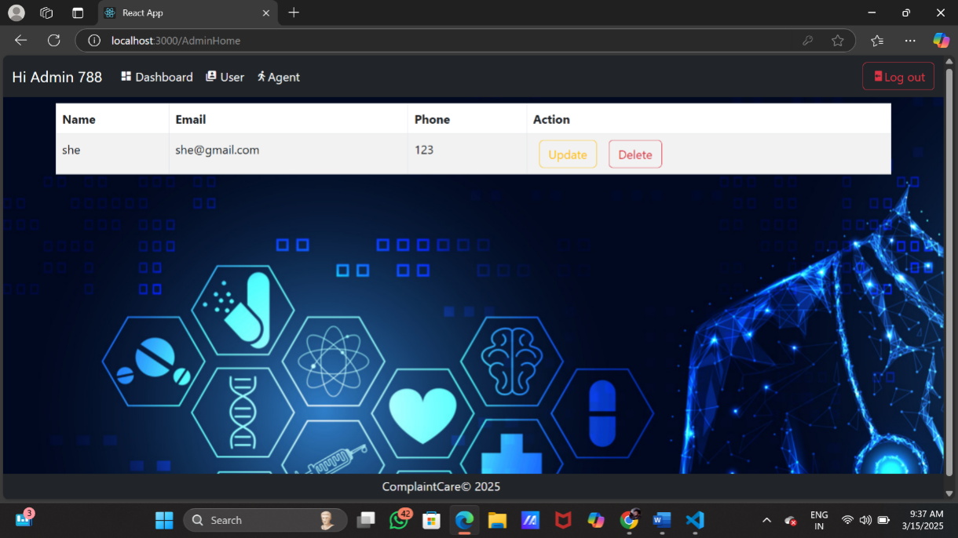

**User Complaints Register:**

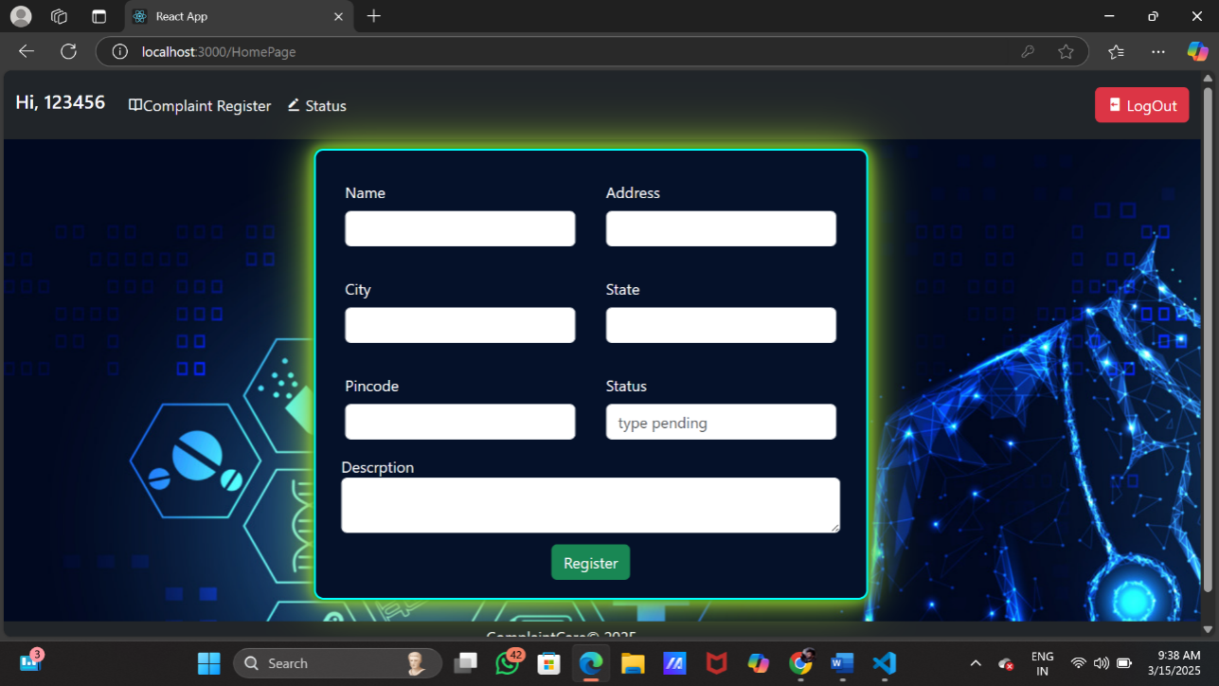

**User status:**

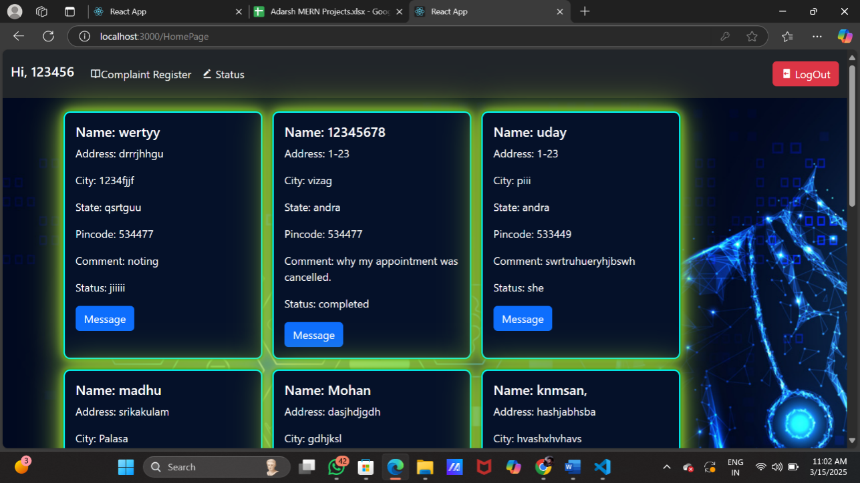

**Agent Home:**

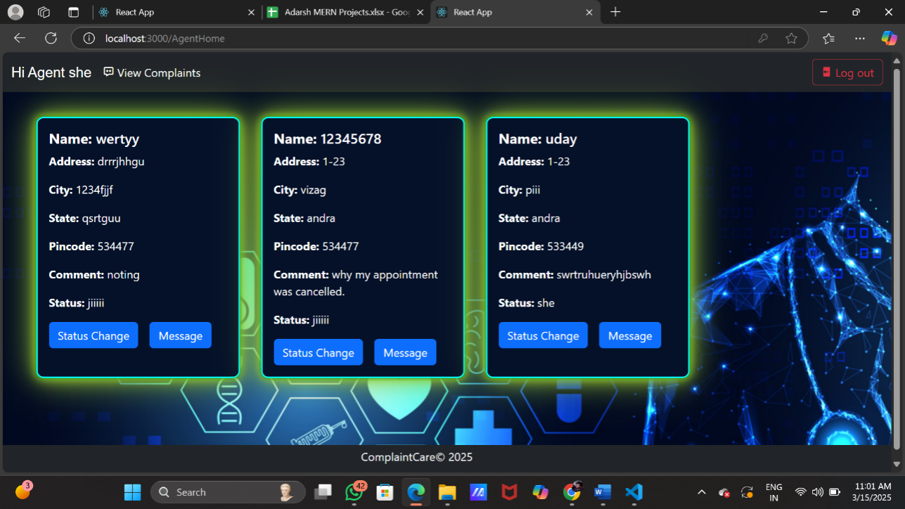

**Testing:**

**Purpose:** To validate that the application meets user requirements and expectations.

* Users test the entire application to ensure it meets their needs and provides a good user experience.
* Gathering feedback from users and stakeholders to make improvements.
* Here are some details on testing the MEAN stack application:
* Testing Strategy
* Unit Testing
* - Use Jest or Mocha for unit testing
* - Test individual components, services, and controllers
* - Use mocking libraries like Jest. mock or Sinon.js to isolate dependencies
* Integration Testing
* - Use Jest or Mocha for integration testing
* - Test how multiple components, services, and controllers interact with each other
* - Use a test database to test data access and manipulation
* End-to-End (E2E) Testing
* - Use Cypress or Protractor for E2E testing
* - Test the entire application from a user's perspective
* - Use a test environment to simulate user interactions
* Testing Tools
* Backend Testing Tools
* - Jest: A popular testing framework for JavaScript
* - Mocha: A widely-used testing framework for Node.js
* - Chai: An assertion library for Node.js
* - Sinon.js: A mocking library for Node.js
* Frontend Testing Tools
* - Jest: A popular testing framework for JavaScript
* - Cypress: A fast and easy-to-use E2E testing framework
* - Protractor: A popular E2E testing framework for Angular applications
* Testing Libraries
* - @angular/core/testing: A testing module for Angular
* - @nestjs/testing: A testing module for Nest.js
* - mongoose: A popular MongoDB ORM for Node.js
* Testing Best Practices
* Write Testable Code
* - Keep functions and methods short and focused
* - Use dependency injection to make dependencies easier to mock
* - Avoid complex logic and nested conditionals
* Write Comprehensive Tests
* - Test happy paths and edge cases
* - Use mocking libraries to isolate dependencies
* - Test for expected errors and exceptions
* Use Continuous Integration and Continuous Deployment (CI/CD)
* - Use a CI/CD pipeline to automate testing and deployment
* - Use a testing framework that integrates with your CI/CD pipeline
* - Use a code coverage tool to measure test coverage

**Known Issues:**

**Backend Issues**

1. MongoDB Connection Issues: Difficulty connecting to the MongoDB database, resulting in errors when trying to access or manipulate data.

2. Node.js Version Compatibility: Issues with compatibility between different versions of Node.js, which can cause errors when trying to install or run dependencies.

3. Express.js Routing Issues: Problems with routing in Express.js, such as incorrect routing or issues with route parameters.

4. Error Handling: Inadequate error handling, which can cause the application to crash or behave unexpectedly when errors occur.

Frontend Issues

1. Angular Version Compatibility: Issues with compatibility between different versions of Angular, which can cause errors when trying to install or run dependencies.

2. Template Syntax Errors: Errors in the template syntax, such as incorrect use of Angular directives or binding.

3. Component Communication Issues: Problems with communication between components, such as issues with input binding or event emission.

4. CSS Styling Issues: Problems with CSS styling, such as issues with layout or responsive design.

Database Issues

1. MongoDB Schema Design: Issues with the design of the MongoDB schema, such as inadequate indexing or poor data normalization.

2. Data Consistency: Problems with data consistency, such as issues with data validation or concurrency control.

3. Query Performance: Issues with query performance, such as slow query execution or inadequate indexing.

4. Data Security: Problems with data security, such as issues with authentication or authorization.

Deployment Issues

1. Server Configuration: Issues with server configuration, such as problems with port configuration or SSL/TLS setup.

2. Deployment Scripts: Problems with deployment scripts, such as issues with file copying or environment variable setup.

3. Containerization: Issues with containerization, such as problems with Dockerfile configuration or container networking.

4. CI/CD Pipelines: Problems with CI/CD pipelines, such as issues with pipeline configuration or test execution.

Security Issues

1. Authentication: Issues with authentication, such as problems with password storage or authentication protocol configuration.

2. Authorization: Problems with authorization, such as issues with role-based access control or permission configuration.

3. Data Encryption: Issues with data encryption, such as problems with SSL/TLS setup or encryption algorithm configuration.

4. Input Validation: Problems with input validation, such as issues with data sanitization or validation rule configuration**.**

**Database Connection Issues**

* **Problem:** Difficulty connecting to MongoDB, especially in production environments.
* **Solution:** Ensure your MongoDB URI is correct and includes the username, password, and database name. If using MongoDB Atlas, make sure your IP address is whitelisted. Check that your MongoDB server is running if it's a local database.

**Project Structure**

Backend (Node.js, Express, MongoDB)

- app.js: Main application file

- config: Configuration files for the application

- database.js: Database configuration

- server.js: Server configuration

- controllers: Controller files for handling requests

- userController.js: Controller for user-related requests

- todoController.js: Controller for todo-related requests

- models: Model files for interacting with the database

- userModel.js: Model for user data

- todoModel.js: Model for todo data

- routes: Route files for handling requests

- userRoutes.js: Routes for user-related requests

- todoRoutes.js: Routes for todo-related requests

- services: Service files for business logic

- userService.js: Service for user-related business logic

- todoService.js: Service for todo-related business logic

- utils: Utility files for miscellaneous functions

- auth.js: Utility for authentication

- error.js: Utility for error handling

Frontend (Angular):

- e2e: End-to-end test files

- node_modules: Node.js modules installed by npm or yarn

- src: Source files for the Angular application

- app: Application files

- app.component.html: HTML template for the app component

- app.component.ts: TypeScript file for the app component

- app.module.ts: TypeScript file for the app module

- assets: Asset files for the application

- images: Image files

- styles: CSS files

- environments: Environment files for the application

- environment.ts: TypeScript file for the environment

- environment.prod.ts: TypeScript file for the production environment

- models: Model files for the application

- user.model.ts: TypeScript file for the user model

- todo.model.ts: TypeScript file for the todo model

- services: Service files for the application

- user service.ts: TypeScript file for the user service

- todo service. ts: TypeScript file for the todo service

- components: Component files for the application

- user: User-related component files

- todo: Todo-related component files

Database (MongoDB)

- users: Collection for user data

- todos: Collection for todo data

* **Problem:** Poorly structured project architecture leading to maintainability issues.
* **Solution:** Follow a structured project layout with separate folders for models, controllers, routes, and services. Use the MVC (Model-View-Controller) architecture for better code maintainability.

Future Enhancement:

. Real-Time Resolution Dashboards

Live Tracking & Transparency: Develop real-time resolution dashboards where customers can track the status of their complaint at each stage (submitted, under review, resolved) and communicate directly with healthcare providers or administrators.

Feedback Loops: Allow users to rate their experience with the complaint resolution process, helping healthcare organizations track satisfaction and improve customer service.

**Improved User Interface and Experience:**

* **Dark Mode:** Offer a dark mode option to reduce eye strain and improve readability in low-light conditions.
* **Responsive Design:** Ensure the application is fully responsive and provides a seamless experience across all devices, including smartphones, tablets, and desktops.